

Fruits
Grains
Protein
Vegetables
Dairy

YOUR DETAILS

Name :

Class :

School Name :

ONE TEAM
ONE FAMILY
ONE COMMUNITY

CHALLENGE!!

Can you draw and colour in the club badge within 11 Minutes?

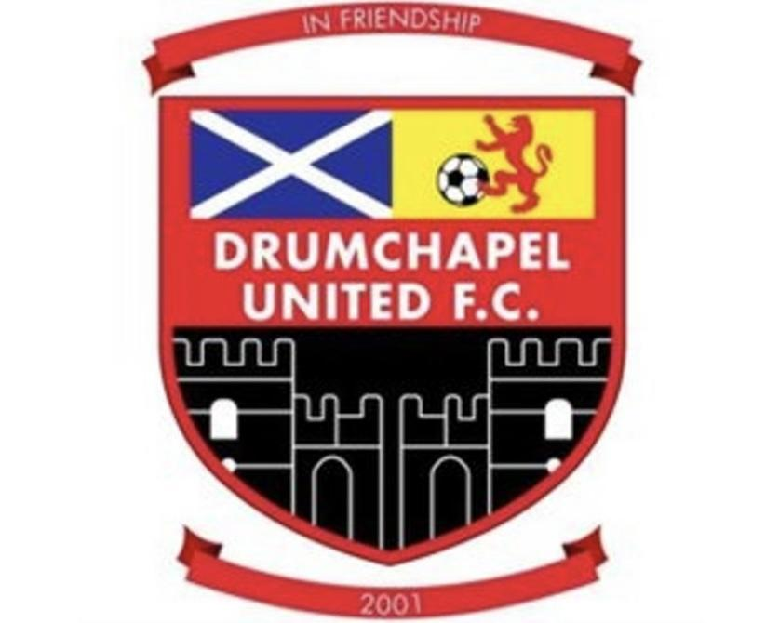

LEARNING BRAIN HEALTH THROUGH FOOTBALL

INTRODUCTION

What does STARS stand for?

S

T

A

R

S

SPENDING TIME WITH FAMILY AND FRIENDS

Work in teams to discuss and design your own football strip and boots.
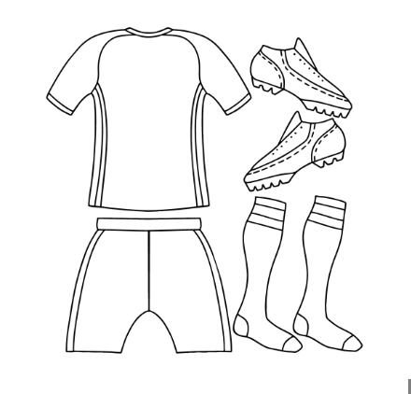

TUCKING INTO HEALTHY FOOD

Can you guess what a professional footballer’s diet may look like?

BREAKFAST

LUNCH

DINNER

ACTIVE AND HEALTHY
CHALLENGE!! Please tick below on how you feel after.

5 VIGOROUS
Cannot talk.
Breathing fast and heavy
Soaking in sweat
Very tired
4MODERATE to VIGOROUS
Breathing fast
Tired
Talk is broken.
Sweating alot

3 MODERATE
Getting tired
Sweating
Breathing a little fast
Talking is lightly broken.

2 LOW
A little tired
Talking is fine.
Getting warm
Breathing slightly increased

1 EASY
Not tired at all
Feeling good
Talking as normal
Breathing regular

REST AND RELAX

A footballer who has more, or better-quality sleep
can be less likely to get injured?

TRUE FALSE

How many hours of sleep did you get?

What time did you go to sleep last night?

SAFETY - KEEPING OUR HEAD SAFE

WHATS YOUR RECORD? CAN YOU BEAT THIS NEXT WEEK?

BE A BRAIN HEALTH CHAMPION

Fill out below and set a goal to improve your brain health

I will

How

When

Where

With


HEALTHY EATING WORKSHEET

Task 1

Build the plate by colouring each food group into the correct plate.

Fruits
Grains
Protein
Dairy
Vegetables

TASK 2

…………… Helps our bodies heal

…………….Like bread, cereal and pasta help turn the foods we eat into energy for our body

…………Foods like milk, yogurt and cheese help build strong bones and teeth

…………..Foods like meat, beans and nuts help build strong muscles

……………….Help us have healthy skin and eyes

TASTE, TOUCH, SMELL CHALLENGE!

With the foods given, Please rank from 1- Enjoyed the most to 10- Didn’t enjoy at all.

BANANA ORANGE PEARS WATERMELON

GRAPES CRANBERRY JUICE KIWI MELON

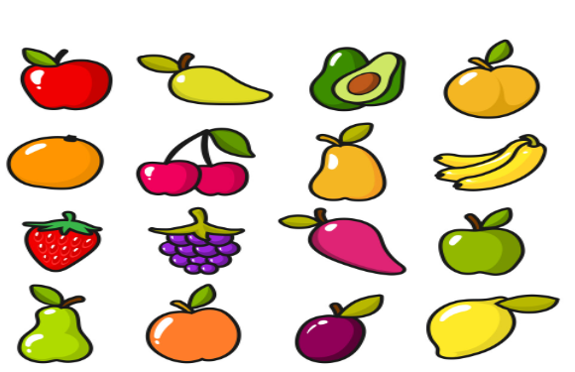
MANGO CHERRY

TASK 1 - EQUALITY AND INCLUSION

Circle different types of people/groups that you see being included and involved in football in the video.

1. Children (U16) 6. Coaches

2. Young People (16-24) 7. Referees

3. Adults 8. Para - Football

4. Different Genders 9. People with different hobbies

5. People from different religious 10. Grounds people
Backgrounds

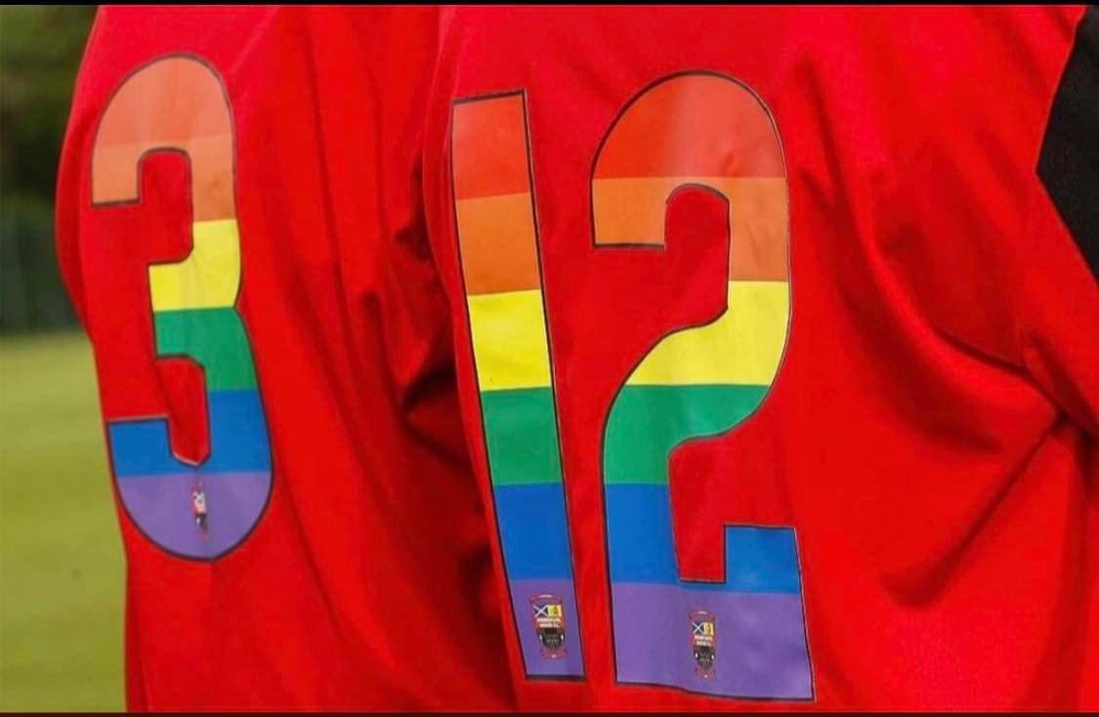
#FOOTBALL

TASK 2 Equality and inclusion

Creating a poster highlighting football is for everyone.

TASK 3 -

Think back to the games you have played while you were outside, How can you make them more fun / enjoyable for your classmates, Design how it would look.
With equipment, footballs and players.



Task 4 -
Reflection question - Think about all the things that make you who you are?
Feel free to use words or drawings!

LEADERSHIP WORKSHEET

TASK 1
List below who is in your team.

TASK 2
Your Game
Write below the game your team has selected to deliver.

TASK 3
Discuss the game you have selected and consider the equipment you may need:

Number of Footballs Numbers of markers

Do you need goals scorekeepers / Referees

TASK 4
Discuss in your group the roles and responsibilities of each person on the day.

About the Club -

Drumchapel United is a community award winning grassroots football club formed in 2001.

- Full player pathways for boys and girls
- Large community programme to get involved in football, make friends and be active
- Primary and secondary school sessions
- Educational programmes

Community Sessions -
Monday’s | McDonald’s academy 5-11 years (Boys)  Cashback session for 12-16 years (Boys)
Tuesday’s | Mini kickers session (2021) 5-6  Mini kickers session (2020) 6-7
Wednesday’s | Boys Autism session Ages 9-17 5-6pm
Thursday’s | Disney playmakers 5-8 years (Girls) 5-6pm  McDonald’s Girls academy 8-11years 5-6pm  McDonald’s Girls academy 12-15 years 5-6pm
Friday’s | Jewson academy 5-11 years (Boys) 5-6pm  Cashback session for 12-16 years (Boys) 5-6pm

If you require any more information from any of the above, please contact the official club email or other social media platforms below:

Email :drumchapelunitedfc@gmail.com
Facebook: DRUMCHAPELUNITEDAFC
X: @DrumchapelU
Instagram: Drumchapelunitedoffical
Website: www.drumchapelunited.co.uk
Tiktok: drumchapelunited

