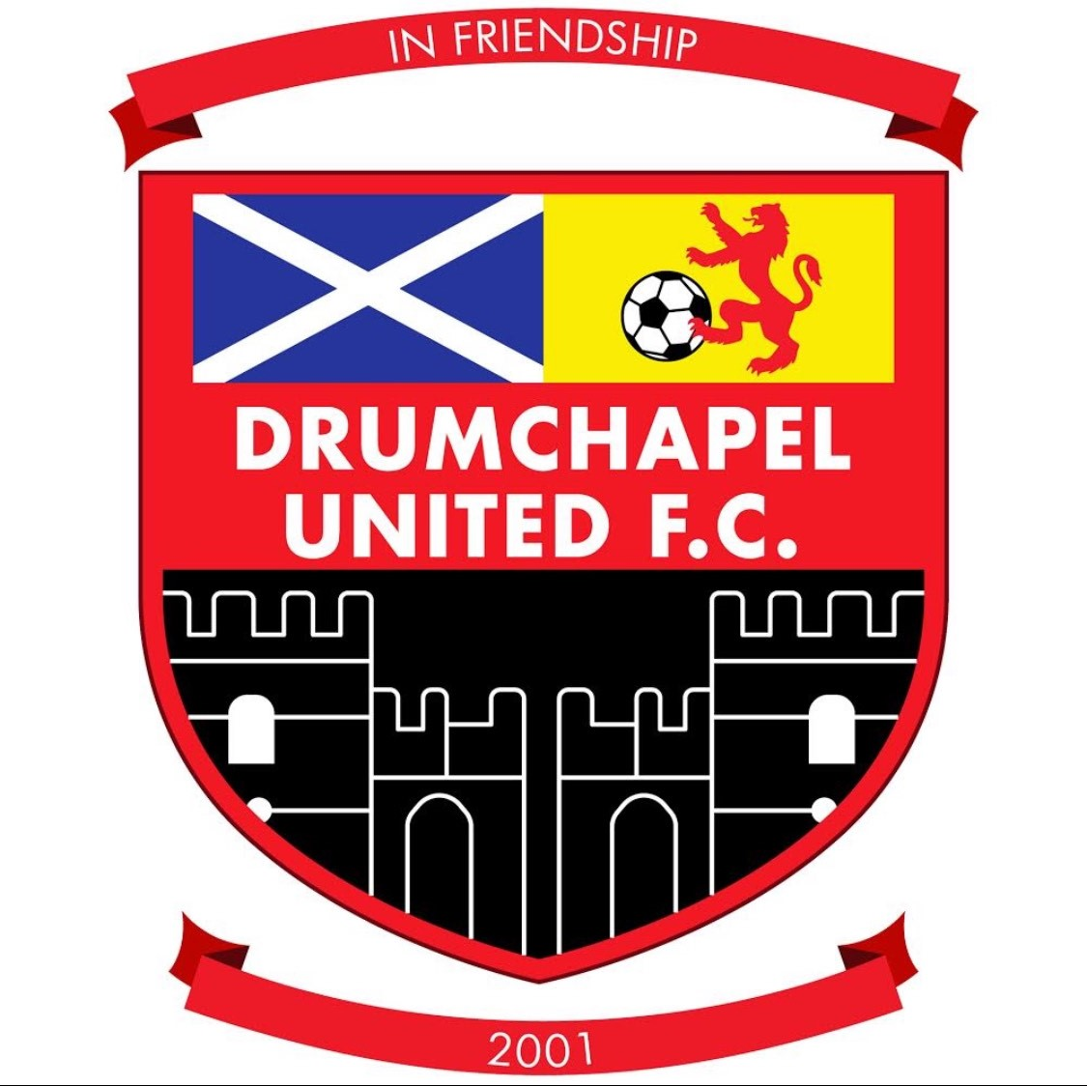

Drumchapel United
Disability Policy

Introduction

Drumchapel United Football Club is committed to ensuring that supporters and customers with accessibility needs have as full access as is reasonably possible to, to all goods, services and facilities provided or offered to the public by the football club. The club recognises its responsibilities in the context of the Equality Act 2010.
The Club recognizes that it must also take into consideration the needs of visiting supporters with accessibility requirements, as well as its’ own, and will liaise with apposing clubs to accommodate supporters with such needs to the best of their ability.
Our community engagement officer has been appointed to act as an intermediary between disabled supporters and the Club’s senior management. Rosie can be contacted by emailing drumchapelunitedfc.rosiebrown@gmail.com
The football Club will ensure that all staff and volunteers are aware of the disability policy and are trained appropriately. Any complaints made against employees will be treated as a serious matter, and if they are found to be in breach of the Equality Act (2010), it will be dealt with under the Club’s Disciplinary Procedures.

Access
A Drumchapel United disability season ticket entitles the holder to attend all home league games. When required, and eligibility criteria is met, a personal assistant ticket will be issued at no extra cost. Personal Assistant tickets will only be permitted to enter the stadium when accompanying a disabled season ticket holder.
Visually Impaired Supporters Guide dogs will be permitted within the Stadium as per the Club’s Policy. Where supporters require the assistance of a Guide Dog, they should contact the Club prior to a match, and a suitable area will be identified to provide adequate space for both them and the dog.
For home and away support, we have 3 wheelchair spaces in our covered shelter. Currently, all wheelchair spaces are on a fist come basis and Rosie should be emailed for space to be made available.
Access to the covered shelter area is from the single gate after the entrance to the Donald Dewar centre. Steward will be on hand to help support you to the specific area.

Parking
There are four disabled parking areas located close to the stadium. There are NOT pre-bookable and will be on a first come first serve basis. These spaces are at the top of the hill within the Donald Dewar carpark.

